S3(Simple storage service)

- Create s3 bucket and upload some objects to s3.

Using AWS CLI
- Create an S3 bucket:
aws s3api create-bucket --bucket amaan-test-bucket-for-upload-2025 --region your-region --create-bucket-configuration LocationConstraint=ap-south-1

Replace your-region with your AWS region (e.g., us-east-1, ap-south-1).
- Upload objects:
text
echo "Hello from Amaan's S3 bucket!" > sample1.txt
aws s3 cp sample1.txt s3://amaan-test-bucket-for-upload-2025/sample1.txt

echo "This is a test file for AWS S3 upload." > sample2.txt
aws s3 cp sample2.txt s3://amaan-test-bucket-for-upload-2025/sample2.txt

echo "Boto3 upload successful." > sample3.txt
aws s3 cp sample3.txt s3://amaan-test-bucket-for-upload-2025/sample3.txt
Python code snippet using boto3
python
import boto3

s3 = boto3.client('s3')
bucket_name = "amaan-test-bucket-for-upload-2025"
region = "your-region"

# Create bucket
s3.create_bucket(Bucket=bucket_name,
CreateBucketConfiguration={'LocationConstraint': region})

# Upload objects
s3.put_object(Bucket=bucket_name, Key="sample1.txt", Body="Hello from Amaan's S3 bucket!")
s3.put_object(Bucket=bucket_name, Key="sample2.txt", Body="This is a test file for AWS S3 upload.")
s3.put_object(Bucket=bucket_name, Key="sample3.txt", Body="Boto3 upload successful.")
To proceed with actual AWS service interaction, running the above AWS CLI commands or Python code in a proper AWS-enabled environment is required. If more assistance is needed with this setup or commands, that can be provided.

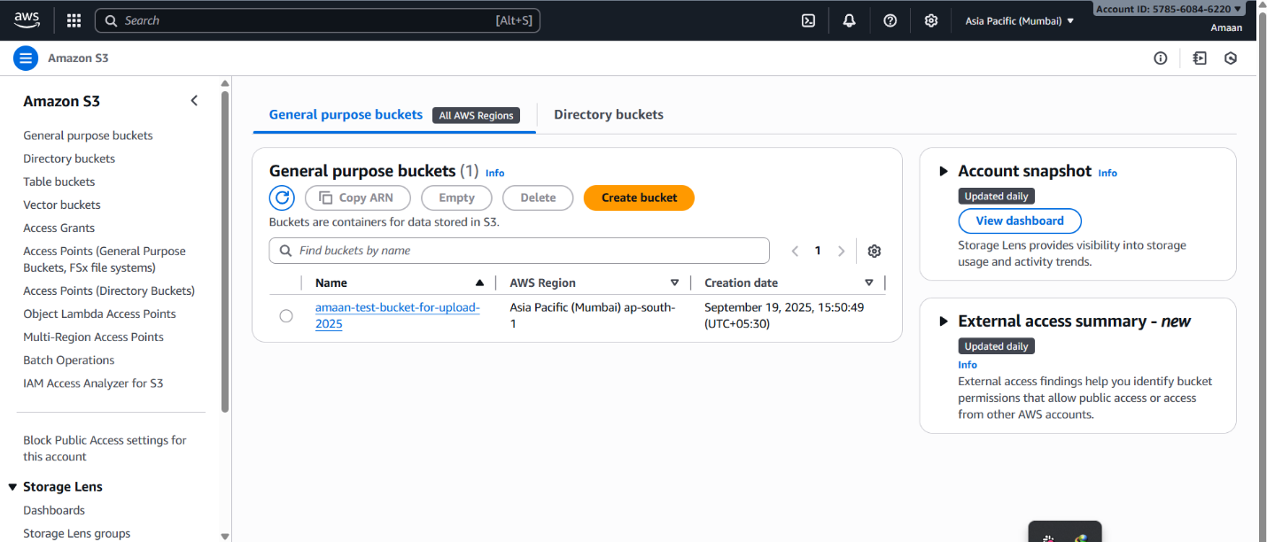

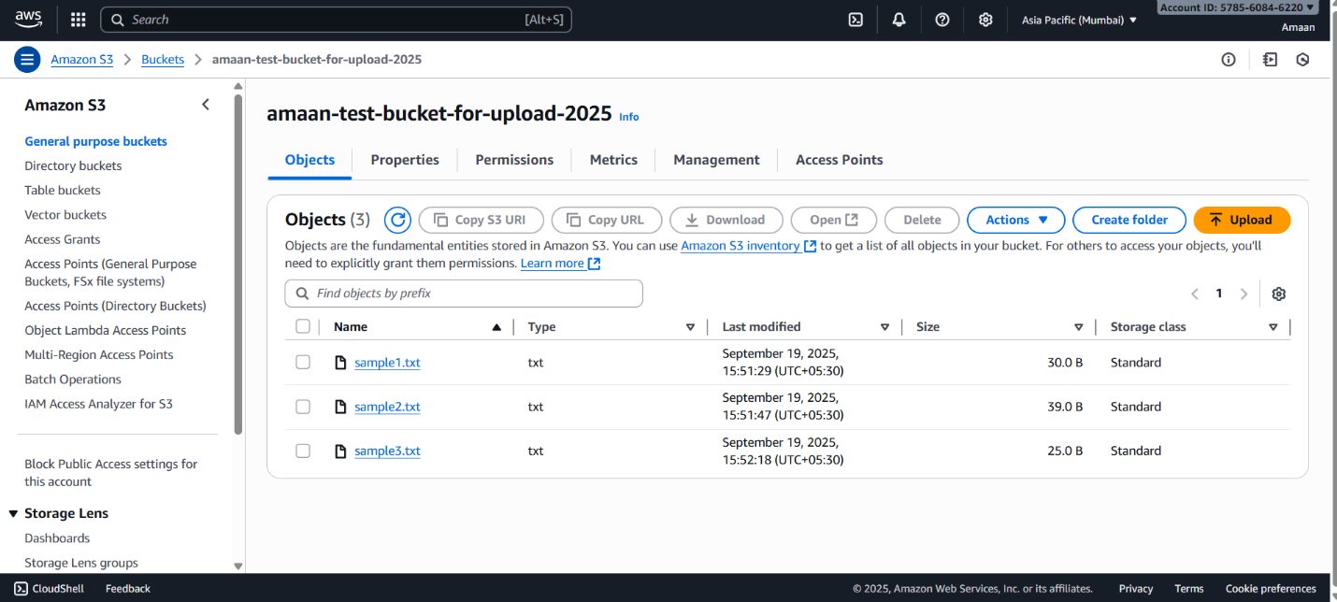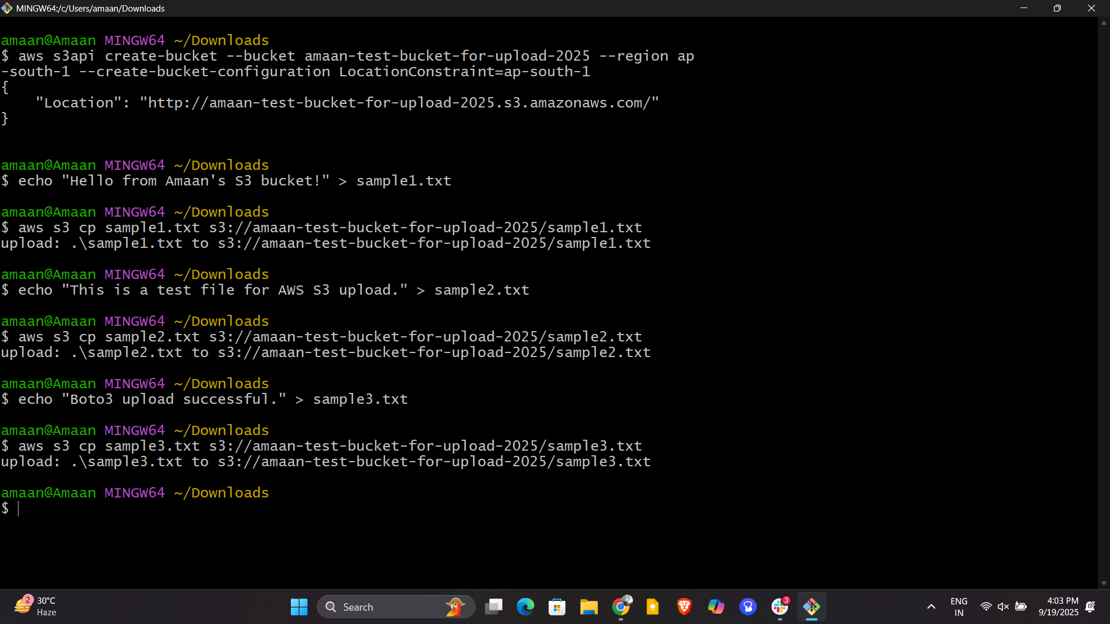
2) Deploy static website in s3 bucket.
Steps to deploy a static website on S3
- Enable static website hosting on the bucket:
Run this AWS CLI command to configure the bucket for website hosting:
bash
aws s3 website s3://amaan-test-bucket-for-upload-2025/ --index-document index.html --error-document error.html
This sets the bucket to serve files as a website with index.html as the homepage and error.html for errors.
- Prepare your website files:
Create an index.html file and optionally an error.html file. For example:
index.html
xml
<!DOCTYPE html>
<html>
<head>
<title>Welcome to Amaan's Static Website</title>
</head>
<body>
<h1>Hello from Amaan's S3 Static Website!</h1>
<p>This site is served from an S3 bucket.</p>
</body>
</html>
error.html
xml
<!DOCTYPE html>
<html>
<head>
<title>Page Not Found</title>
</head>
<body>
<h1>404 - Page not found</h1>
<p>Sorry, the page you are looking for does not exist.</p>
</body>
</html>
- Upload these files to the bucket:
bash
aws s3 cp index.html s3://amaan-test-bucket-for-upload-2025/index.html
aws s3 cp error.html s3://amaan-test-bucket-for-upload-2025/error.html
- Make the files publicly readable:
Since static websites need public access, you must configure a bucket policy to allow public read on objects:
Create a bucket-policy.json file with this content:
json
{
"Version":"2012-10-17",
"Statement":[{
"Sid":"PublicReadGetObject",
"Effect":"Allow",
"Principal": "*",
"Action":["s3:GetObject"],
"Resource":["arn:aws:s3:::amaan-test-bucket-for-upload-2025/*"]
}]
}
Apply the policy with:
bash
aws s3api put-bucket-policy --bucket amaan-test-bucket-for-upload-2025 --policy file://bucket-policy.json
- Access your website:
After these steps, the static website URL will be:
text
http://amaan-test-bucket-for-upload-2025.s3-website.ap-south-1.amazonaws.com/
Open this URL in a browser to see your static website live.

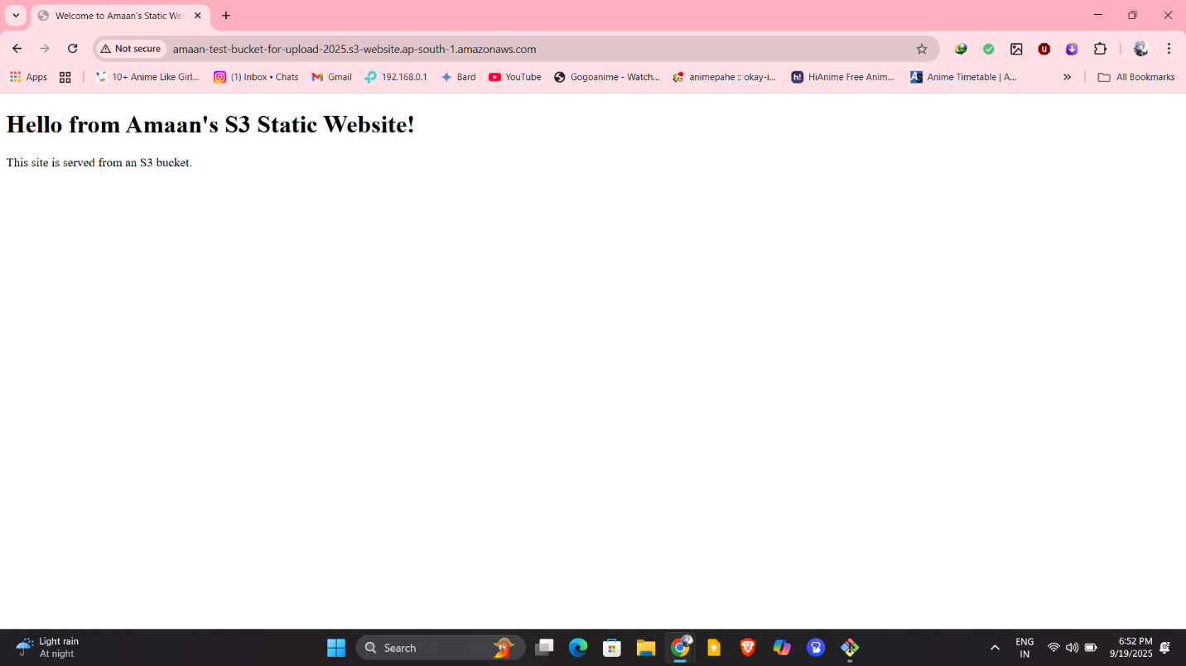
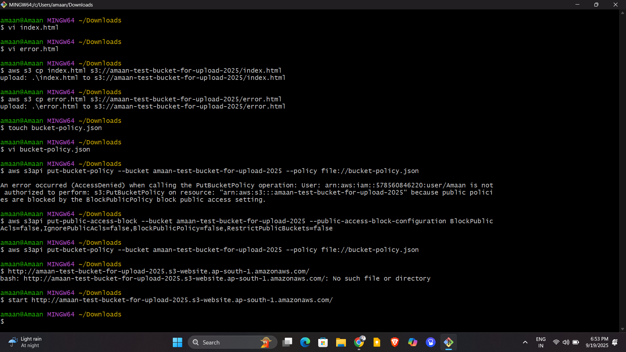

3) Enable cross region replication on s3 buckets.
Task 3: Enable Cross-Region Replication (CRR) on S3 Buckets

Objective:
Set up automatic replication of objects from a source S3 bucket in one AWS region to a destination S3 bucket in a different AWS region.

Detailed Steps:
- Create Destination Bucket in Different Region
Create the destination bucket in a region different from the source bucket. For example, if the source bucket is in ap-south-1, create the destination bucket in us-east-1 or another region.
Example command for destination bucket creation (ap-south-1 used here in your case):
text
aws s3api create-bucket --bucket amaan-replica-bucket-2025 --region ap-south-1 --create-bucket-configuration LocationConstraint=ap-south-1
- Enable Versioning on Both Buckets
Versioning must be enabled on both source and destination buckets.
Example commands:
text
aws s3api put-bucket-versioning --bucket amaan-test-bucket-for-upload-2025 --versioning-configuration Status=Enabled
aws s3api put-bucket-versioning --bucket amaan-replica-bucket-2025 --versioning-configuration Status=Enabled
- Create IAM Role for Replication
  - Create an IAM role that Amazon S3 assumes to replicate objects.
  - Attach a trust policy that allows the S3 service to assume this role.
  - Attach a permission policy granting required replication permissions on the source and destination buckets.
- Set Bucket Policy on Destination Bucket
Allow the IAM replication role to write and replicate objects to the destination bucket by applying a bucket policy granting the appropriate permissions.
- Apply Replication Configuration on Source Bucket
Define and apply a replication configuration JSON on the source bucket, specifying:
  - The IAM role ARN created in Step 3.
  - Source-to-destination replication rule(s).
  - Status enabled.
Apply with this command:
text
aws s3api put-bucket-replication --bucket amaan-test-bucket-for-upload-2025 --replication-configuration file://replication.json
- Verify Replication
  - Newly uploaded objects to the source bucket will be replicated asynchronously to the destination bucket.
  - Monitor replication and replication status through AWS S3 console or CLI.

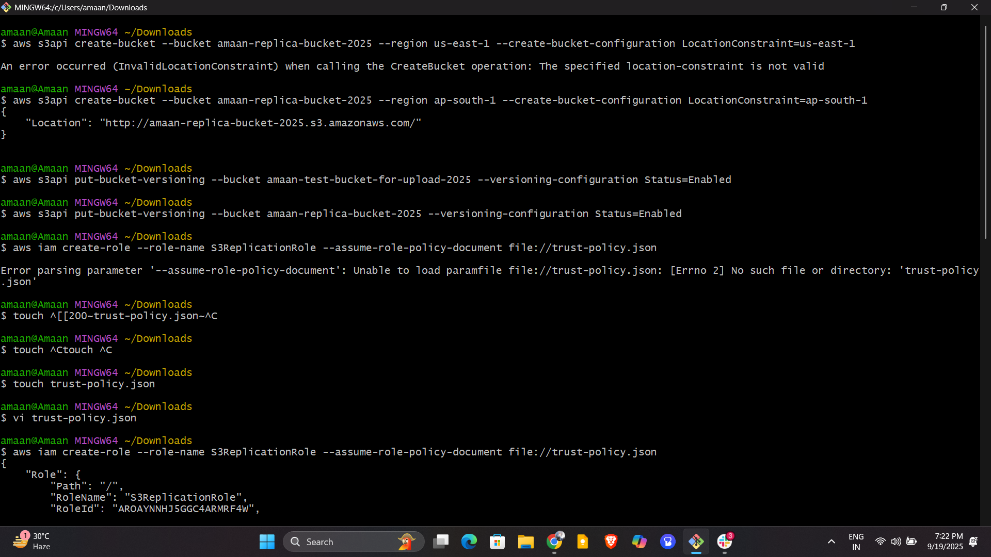
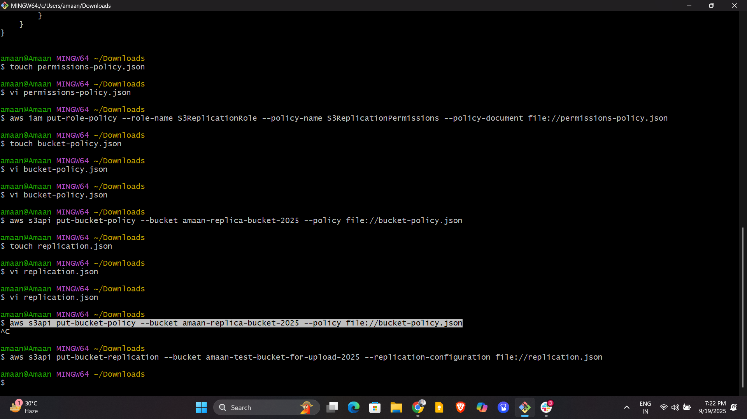
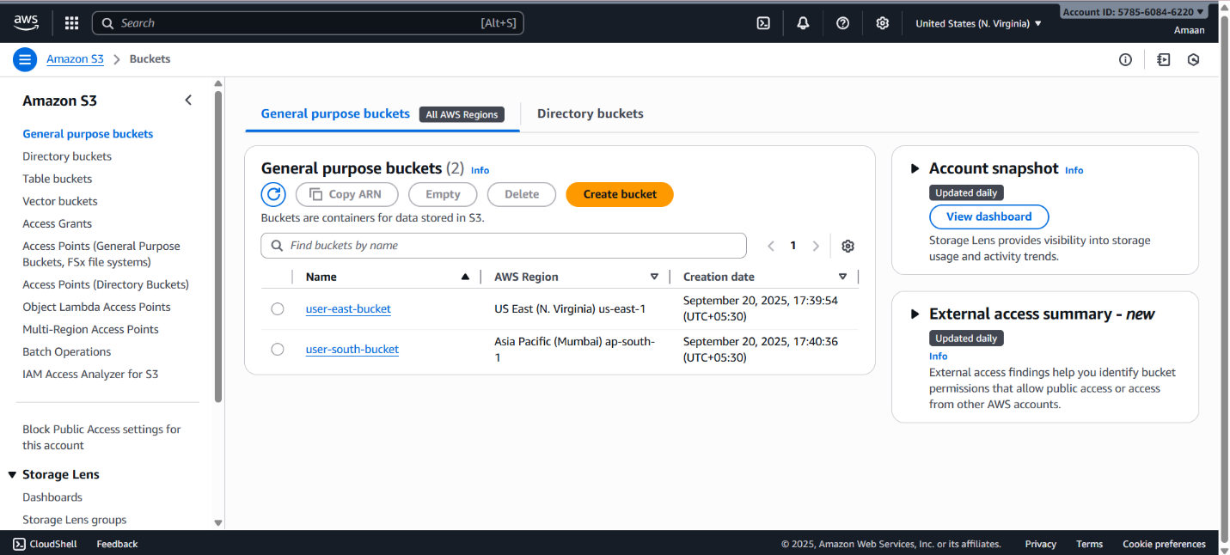
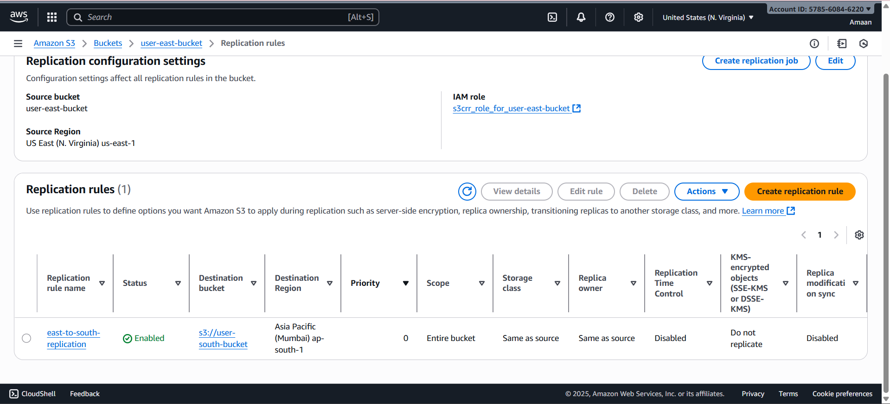
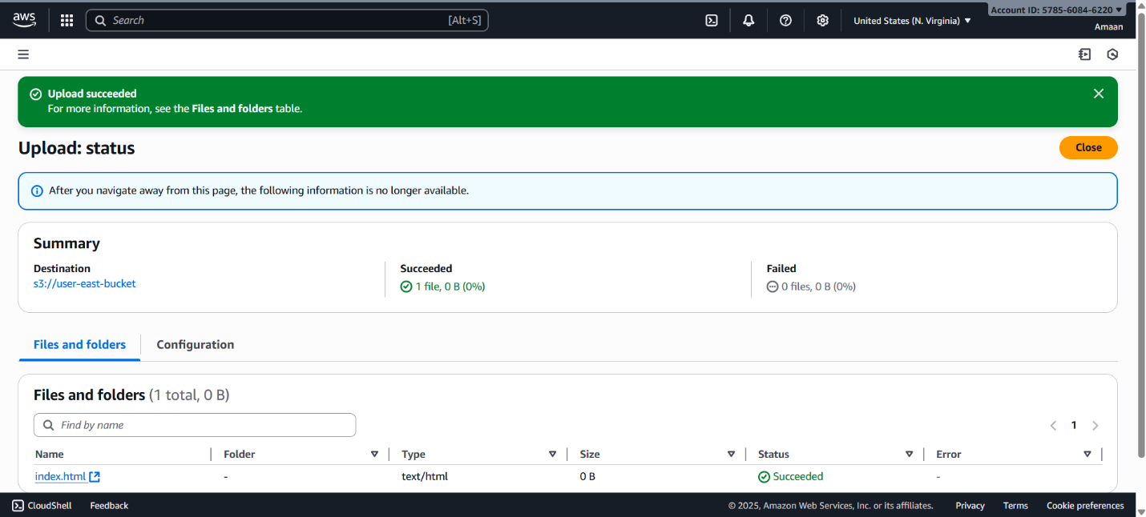
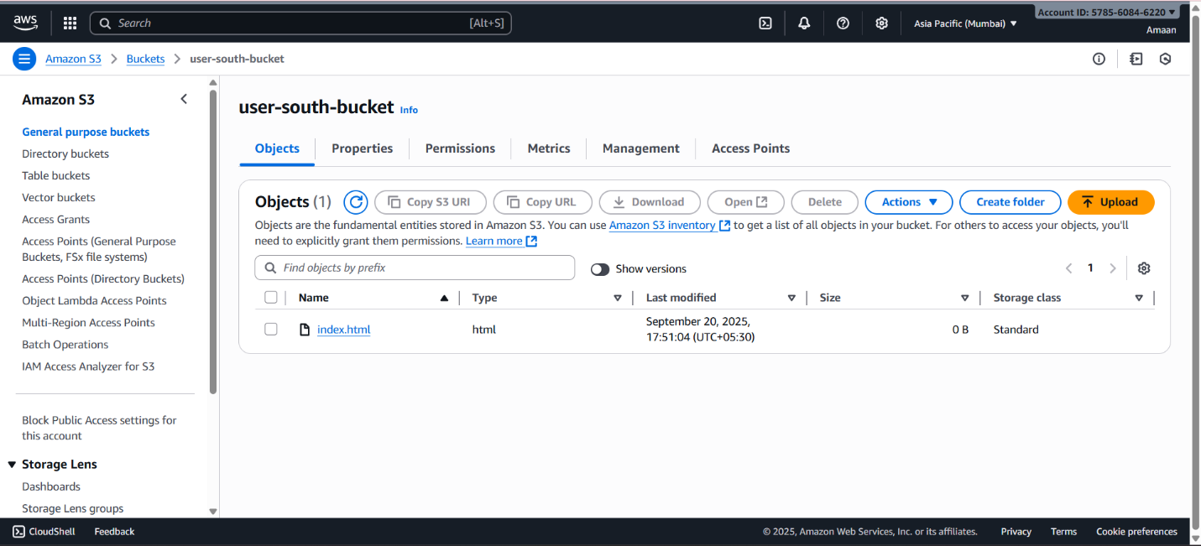
4) Configure bucket policy,only Admin user can see the objects of s3 bucket.

Task 4: Configure Bucket Policy to Restrict Object Access to Only Admin User
Prerequisites:
- An IAM user named Admin is created.
- You know the Admin user's ARN, typically of the form:
arn:aws:iam::ACCOUNT_ID:user/Admin
Steps:
- Open the AWS S3 Console.
- Select the bucket you want to secure.
- Go to the Permissions tab.
- Click Bucket Policy → Edit.
- Paste the following example bucket policy (replace placeholders with your actual bucket name and Admin user ARN):
json
{
"Version": "2012-10-17",
"Statement": [
{
"Sid": "AllowAdminFullAccess",
"Effect": "Allow",
"Principal": {
"AWS": "arn:aws:iam::578560846220:user/Admin"
},
"Action": [
"s3:GetObject",
"s3:ListBucket"
],
"Resource": [
"arn:aws:s3:::awsbucket01xyz",
"arn:aws:s3:::awsbucket01xyz/*"
]
},
{
"Sid": "DenyAllOthersAccess",
"Effect": "Deny",
"NotPrincipal": {
"AWS": "arn:aws:iam::578560846220:user/Admin"
},
"Action": [
"s3:GetObject",
"s3:ListBucket"
],
"Resource": [
"arn:aws:s3:::awsbucket01xyz",
"arn:aws:s3:::awsbucket01xyz/*"
]
}
]
}

How to apply this policy:
- Save the above JSON into a file named bucket-policy.json.
- Run this AWS CLI command to apply it:
bash
aws s3api put-bucket-policy --bucket awsbucket01xyz --policy file://bucket-policy.json
This will ensure only the IAM user "Admin" in your account can view and list the contents of the awsbucket01xyz S3 bucket.

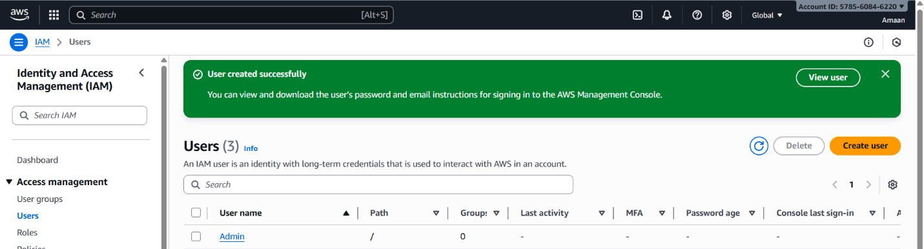
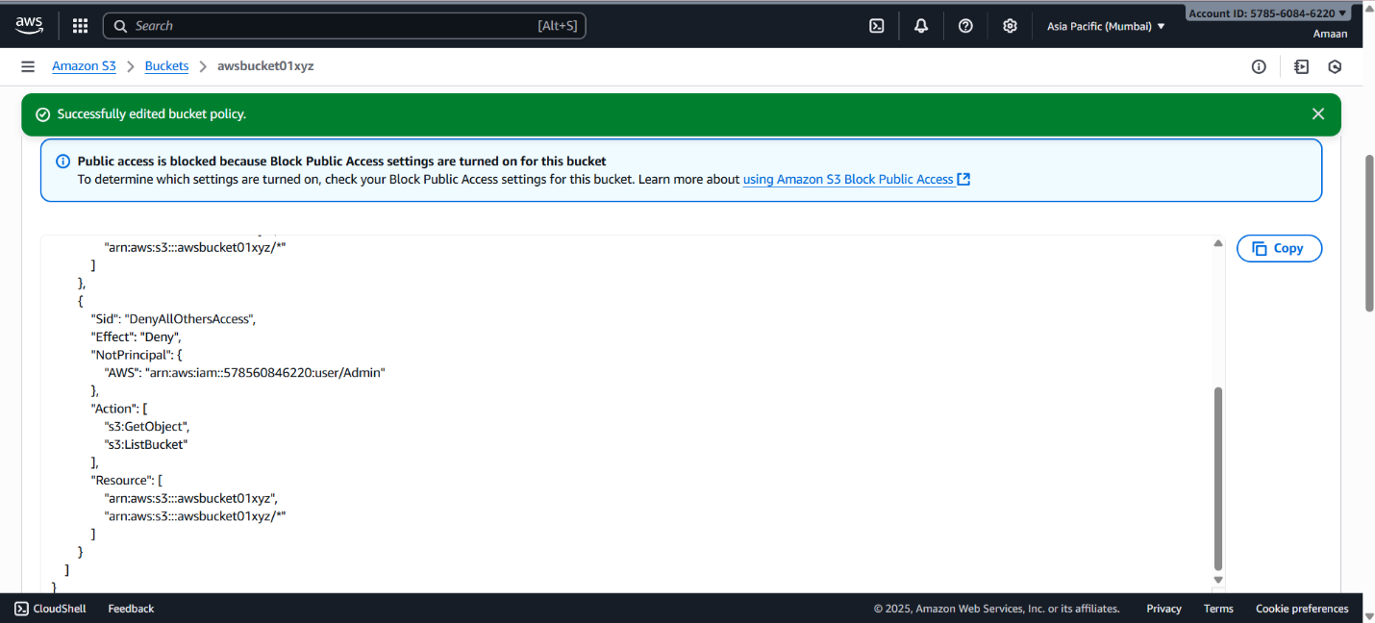
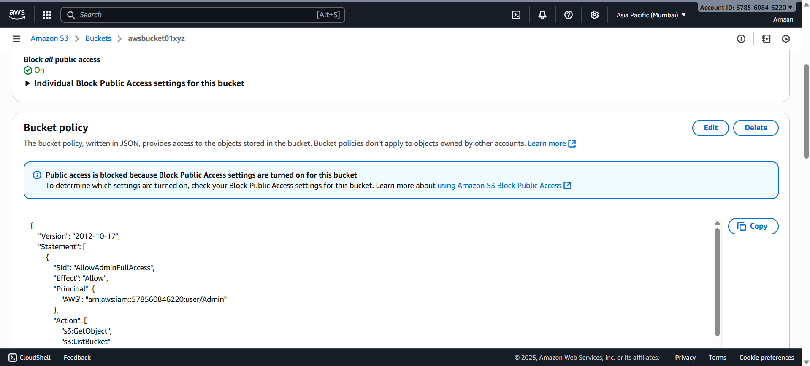

5) Setup lifecycle policies to automatically transition or delete objects based on specific criteria.
Task 5: Setup Lifecycle Policies on S3 Bucket
Objective:
Create rules that automatically transition objects to cheaper storage tiers or delete them after certain criteria (age, date, tag) are met.

Instructions (Console Method):
- Go to AWS S3 Console
Open the AWS Management Console and navigate to S3 service.
- Select your bucket
Choose the bucket you want to configure lifecycle policies for.
- Go to Management tab
Click on the Management tab inside the bucket.
- Create lifecycle rule
  - Click Create lifecycle rule.
  - Give the rule a name (e.g., auto-transition-and-expiration).
  - Choose the scope of the rule: apply to all objects or filter by prefix/tag.
- Configure transitions (Optional)
  - Add transitions to move objects to different storage classes after a number of days. For example:
    - Transition to STANDARD_IA (infrequent access) after 30 days.
    - Transition to GLACIER after 90 days.
- Configure expiration
  - Specify an expiration action to delete objects after a number of days (e.g., delete after 365 days).
  - Optionally, delete incomplete multipart uploads after some days.
- Review and create
  - Review your settings.
  - Click Create rule.

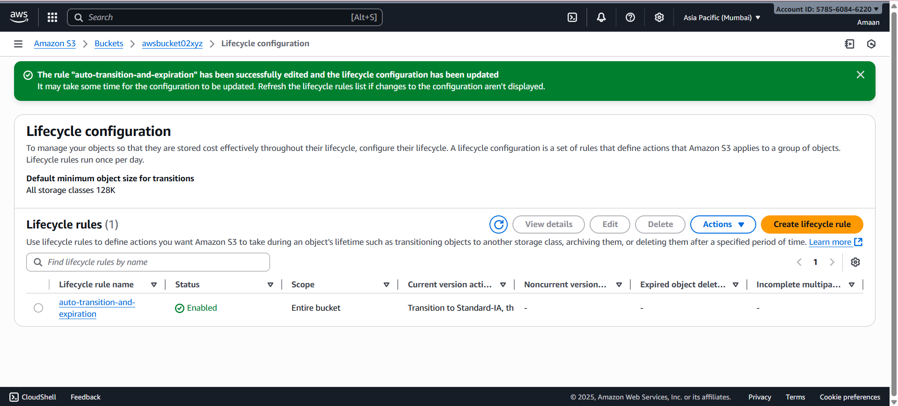
6) Push some objects in s3 using AWS CLI.

Task 6: Push objects to S3 using AWS CLI
Steps:
- Create a sample file
Create a small text file on your local machine, for example:
bash
echo "Hello, this is a test file for S3 upload." > test1.txt
echo "This is another test file for AWS S3 CLI." > test2.txt
- Create or select an S3 bucket
Assume the bucket name: userbucket123
- Upload files to S3 bucket using AWS CLI
bash
aws s3 cp test1.txt s3://userbucket123/test1.txt
aws s3 cp test2.txt s3://userbucket123/test2.txt
- Verify upload
You can check files using:
bash
aws s3 ls s3://userbucket123/

Notes:
- Replace userbucket123 with your actual bucket name.
- Files can be any content, names are simple as requested.
- After completing tests, you can delete the objects and bucket to clean up.
- Let me know if you want the full commands to create the bucket and enable versioning as well.
If you want, I can prepare a script with commands all in one for your task. Just ask! For Task 6, here's how to push objects into an S3 bucket using AWS CLI with simple and short naming:
- Create sample files locally:
bash
echo "Sample content for file 1" > file1.txt
echo "Sample content for file 2" > file2.txt
- Assuming bucket name userbucket123 (you can create if needed):
bash
aws s3api create-bucket --bucket userbucket123 --region ap-south-1 --create-bucket-configuration LocationConstraint=ap-south-1
- Upload the files to the bucket:
bash
aws s3 cp file1.txt s3://userbucket123/file1.txt
aws s3 cp file2.txt s3://userbucket123/file2.txt
- Verify upload:
bash
aws s3 ls s3://userbucket123/
After completing this, remember to delete the bucket and files to clean up as per your note.

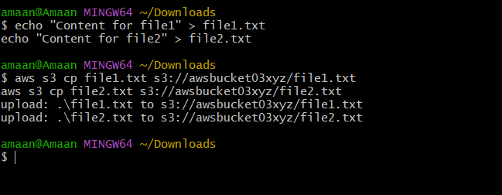
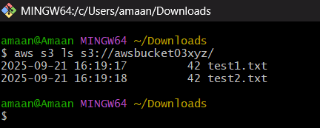
7) Write a bash script to create s3 bucket.

Task 7: Bash Script to Create S3 Bucket
bash
#!/bin/bash

# Variables
BUCKET_NAME="userbucketxyz"
REGION="ap-south-1"

# Check if bucket name is provided as argument optionally
if [ ! -z "$1" ]; then
BUCKET_NAME=$1
fi

# Create the S3 bucket
echo "Creating S3 bucket: $BUCKET_NAME in region: $REGION"
aws s3api create-bucket --bucket $BUCKET_NAME --region $REGION --create-bucket-configuration LocationConstraint=$REGION

# Enable versioning on the bucket
echo "Enabling versioning on bucket: $BUCKET_NAME"
aws s3api put-bucket-versioning --bucket $BUCKET_NAME --versioning-configuration Status=Enabled

echo "Bucket $BUCKET_NAME created and versioning enabled successfully."

Usage:
- Save this script to a file, e.g., create_s3_bucket.sh.
- Make it executable:
bash
chmod +x create_s3_bucket.sh
- Run the script without argument to create the default bucket name:
bash
./create_s3_bucket.sh
Or specify a bucket name:
bash
./create_s3_bucket.sh mycustombucketname123

This script will create an S3 bucket in the ap-south-1 region and enable versioning on it. You can change the region in the script if needed.
Remember to delete the buckets after completing your tests to avoid charges.
Let me know if you want the script adjusted or need scripts for other tasks too!Here is a simple Bash script to create an S3 bucket using AWS CLI. The bucket name is short and simple as requested.

Task 7: Bash Script to Create S3 Bucket
bash
#!/bin/bash

# Variables
BUCKET_NAME="userbucketxyz"
REGION="ap-south-1"

# Check if bucket name is provided as argument optionally
if [ ! -z "$1" ]; then
BUCKET_NAME=$1
fi

# Create the S3 bucket
echo "Creating S3 bucket: $BUCKET_NAME in region: $REGION"
aws s3api create-bucket --bucket $BUCKET_NAME --region $REGION --create-bucket-configuration LocationConstraint=$REGION

# Enable versioning on the bucket
echo "Enabling versioning on bucket: $BUCKET_NAME"
aws s3api put-bucket-versioning --bucket $BUCKET_NAME --versioning-configuration Status=Enabled

echo "Bucket $BUCKET_NAME created and versioning enabled successfully."

Usage:
- Save this script to a file, e.g., create_s3_bucket.sh.
- Make it executable:
bash
chmod +x create_s3_bucket.sh
- Run the script without argument to create the default bucket name:
bash
./create_s3_bucket.sh
Or specify a bucket name:
bash
./create_s3_bucket.sh mycustombucketname123

This script will create an S3 bucket in the ap-south-1 region and enable versioning on it. You can change the region in the script if needed.
Remember to delete the buckets after completing your tests to avoid charges.

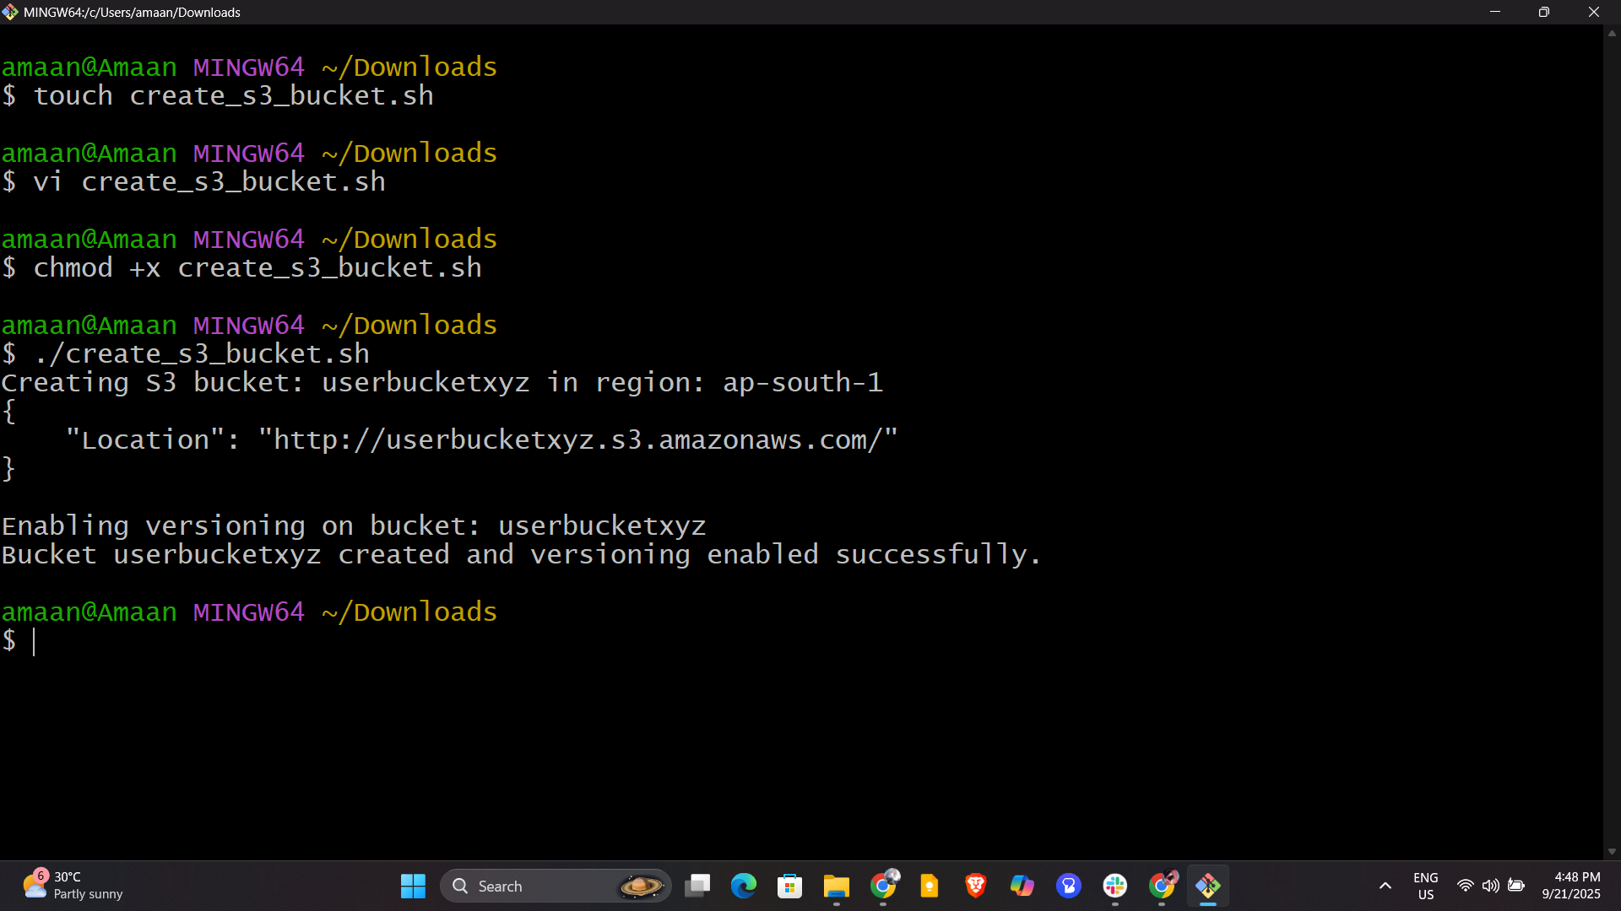
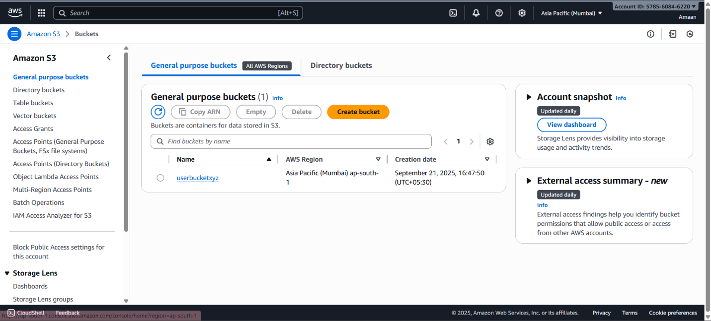
8) Upload one 1 gb of file to s3 using cli.

Task 8: Upload 1 GB File to S3 Using AWS CLI

Step 1: Create a 1 GB file locally
If your environment is Linux/Unix/bash compatible, use this command to create a 1 GB dummy file called bigfile.bin:
bash
fallocate -l 1G bigfile.bin
If fallocate is not available, this alternative using dd works:
bash
dd if=/dev/zero of=bigfile.bin bs=1M count=1024
This creates a 1 GB file filled with zeros.

Step 2: Upload the file to your S3 bucket
Assuming your bucket name is userbucketsample123, upload with:
bash
aws s3 cp bigfile.bin s3://userbucketsample123/bigfile.bin

Step 3: Verify the upload
Check the file in the bucket with:
bash
aws s3 ls s3://userbucketsample123/

Notes:
- Replace userbucketsample123 with your actual bucket name.
- Confirm sufficient network bandwidth and storage before upload.
- Delete the file locally after upload to free space.
- Remember to delete the uploaded file and bucket to avoid charges post testing.

